


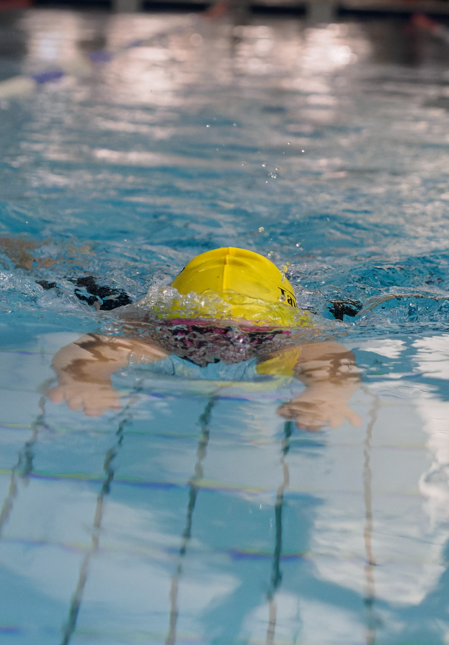

DARTMOOR SPRINT MEET
DEVELOPMENT GALA, BY INVITATION
EXMOUTH LEISURE CENTRE
Saturday 29th March 2025

50m all strokes
100m IM
Age groups: 8&9, 10, 11, 12, 13, 14, 15+.
(Ages as at 29th March 2025)
£5.50/ event; £25 for all five events

Heat Declared Winners
Awards to first 6 in each age group - 12 and under
Awards to first 3 in each age group - 13 and over

Entry Administrator: Caroline Furze on taviswimclubcompetitions@gmail.com

Closing date Sunday 7th March 2025
NOT first come first served: if oversubscribed, entries will be reduced by random selection

Level 4 Licence: 4SW250461
Clubs participating: Brixham, Dawlish, Exeter City, Exmouth, Launceston, Newton Abbot, Plymouth RNRM, Tavistock
Dartmoor Sprint Meet
Saturday 29th March 2025
Swim England Level 4 Licence 4SW250461
PROMOTERS’ CONDITIONS AND INFORMATION

- The Dartmoor Sprint Meet is licensed at Level 4 and shall be held under Swim England Laws and Regulations and Swim England Technical Rules of Racing. The promoters are Tavistock Swimming Club and Exmouth Swimming Club.

- This is a “by invitation” Level 4 meet to which a maximum of six other clubs will be invited, initially out of Brixham, Dawlish, Honiton, Exeter City, Launceston, Newton Abbot, Okehampton, Paignton, Plymouth RN/RM and Tiverton. In the event that six of those clubs do not take up the invitation, the promoter may invite other clubs to reach the total.

- The competition will be held at Exmouth Leisure Centre, The Royal Avenue, Exmouth EX8 1EN. The pool is 25m long, with depth of 2m at the start end and 1m at the turn end. It has six lanes with anti-wave lane ropes.

- Manual timing shall be in operation with the addition of Dolphin Infinity timing if available. There will be no secondary strobe or backstroke ledges.

- Entries will only be accepted from competitors registered as Club Train or Club Compete members of Swim England and who are members of clubs invited to enter.

- Age Groups: competitor’s age groups shall be defined as on the day of the meet, 29 March 2025.
Open: 8 & 9, 10, 11, 12, 13, 14, 15+.
Female: 8 & 9, 10, 11, 12, 13, 14, 15+.

- The Female category is for birth sex females in accordance with Swim England’s Transgender and Non-Binary Competition Policy. By entering the ‘Female’ category, a swimmer confirms that their birth sex is female. If meet software lists the Open category as Male, this should be taken to mean Open (i.e. any competitor not eligible for the Female category).

- There are no qualifying times for this meet. Please submit short course pool times. “No Time” entries will be accepted.

- This is primarily a Development gala aimed at those swimmers new to competing and those less experienced in competition.
  - Any swimmer who has swum at regional or national level in any event since 1 August 2024 and/ or achieved a Swim England SW regional entry/ consideration time in any event since 1 September 2024 will not be eligible for entry into this meet. If any swimmers achieve a regional entry or consideration time after the closing date, they will be required to withdraw their entry and their entry fee(s) will be refunded.
  - County qualifiers are able to take part in this gala, but anyone who achieved a consideration time for the Devon Age Group Championships 2025 will not be eligible for awards in the stroke(s) in which they achieved a consideration time. They may enter the event in that/ those stroke(s) but on an exhibition basis only. The times are attached for ease of reference.
  - Swimmers with a SE/IPC swimming classification who under the above restrictions would not be eligible to enter the gala or would be required to enter events on an exhibition basis may take part without restrictions and will be eligible for medals and ribbons alongside able-bodied swimmers but will not be eligible for awards under para.20.

- Medals will be awarded to swimmers placing 1st, 2nd and 3rd in all age groups and all events. In addition, ribbons will be awarded to swimmers placing 4th, 5th and 6th in the age groups 12 years and under.

- Heats will be mixed and will be swum in “spearheaded” seeded heats (slowest heat first), from submitted times, with declared age group winners.

- All events will be HDW.

- Competitors must report to the stewards at the marshalling area at least three heats prior to their heat. It is the responsibility of coaches and swimmers to ensure that swimmers report to the marshalling area in good time. Any swimmer not reporting may be deemed to have withdrawn from that event.

- Swimmers must have passed the SE Competitive Start award in order to start on the blocks. All other swimmers must start in the water.

- All starts will be over the top where possible.

- The one start rule will be in operation during this event.

- As many heats as possible will be run in the time available. The promoters may limit entries if the meet is oversubscribed and would otherwise risk over-running the time allowed. If scratches are required, non-exhibition swimmers will be given reasonable preference. After that, scratches will be made at random across all entries.

- The promoters reserve the right to amend the Programme of Events based on the number of entries for events and the time available per session.

- Disabled swimmers are welcome and will be seeded according to entry times alongside all other entrants. Please let the promoters know as early as possible of any special requirements. Swimmers with a Certificate of Disability or Certificate of Exception should ensure this is presented to the referee prior to each session, as failure to do so may result in disqualification.

- For swimmers who have a SE/IPC swimming classification which has been notified to the promoters in advance, medals will be awarded on a multi-disability basis to the top three in each event: that is, the three who, across all age groups, are nearest to the World Record (measured on a percentage basis) within their own classification. Clubs are responsible for sending a copy of the competitor’s SE/IPC classification to the promoters with their entry or, if the classification is made after entry, as soon as they receive it. If a disabled swimmer has not yet been classified, the promoters may at their discretion accept an informal classification made by the swimmer’s coach.

Entries
- All entries must be made electronically (unless agreed beforehand). After the closing date, clubs will be given the opportunity to check entries in order to correct errors. There will be no changes after this. No changes or entries permitted on the day.

- The submission of entries indicates acceptance of these conditions. All participating competitors are deemed to be aware of these conditions and it is each participating club’s responsibility to make their members aware of them.

- The promoters reserve the right to reject any entry without giving a reason.

- The promoters use a computer to manage entries and results. By submitting entries to the meet consent is given, as required by the Data Protection Act 2018, to the holding of personal information on computer. Personal data such as name, club, entered/achieved times may be made public prior to, during or after the meet (e.g. programs, results, etc.).

- Entry Fees - £5.50 per event; £25 for all five events.

- Closing date for entries is 23.59 on Friday 7 March 2025. Dates of birth, Swim England numbers and fees must accompany entry. BACS to Tavistock Swimming Club; sort code: 08-92-99 (Co-op); account number: 67264478 using reference ‘club name & DART’. Please send Hytek entry file, a pdf entry report, a summary of fees and a screenshot of payment to taviswimclubcompetitions@gmail.com. Failure to submit payment may lead to a club not being permitted to compete.

- Refunds will be given for withdrawals up to midnight on Friday 14 March 2025. No refunds will be given after that date.

- Late entries may be accepted at the discretion of the promoters and only if the event is undersubscribed.

Behaviour and photography
- On acceptance of entries, the swimmer and any supporters agree that their behaviour will be appropriate and respectful and they will abide by these conditions and any rules of the venue. Failure to do so could result in removal or refusal of entry.

- All competitors and other club representatives on the poolside shall comply with any instructions given by Leisure East Devon staff and meet officials and any safety precautions in operation at the centre.

- Changing on poolside is forbidden and the changing village must be used.

- Any and all use of mobile phones and similar devices in changing rooms is prohibited.

- The promoters do not accept responsibility for any loss or damage to property, however caused. Valuables should be left at home. Lockers are available in the changing rooms and should be used for the safekeeping of other belongings. No large bags are allowed on poolside.

- In line with Swim England & Wavepower guidance, anyone wishing to take images (photo or video) are requested to focus on their own children as much as reasonably possible and to avoid including other children in images, particularly if those images are being shared with family and friends or through social media platforms. The full Swim England guidance on Photography can be found in Wavepower, the Swim England Child safeguarding policy and procedures, available at http://www.swimming.org/swimengland/wavepower-child-safeguarding-for-clubs/

- Flash photography is not permitted at the start of any heat.

Cancellation, changes etc.
- If the meet, or any event(s) within it, is cancelled, postponed or altered due to circumstances beyond the control of the promoters, competitors will not be eligible for a full refund of their entry fees. Proportionate refunds will be made if possible once all costs have been paid. If the meet has already begun when it is cancelled, there will be no refunds.

- Any matters concerning the meet not covered in these conditions shall be dealt with in accordance with the laws of the sport and at the discretion of the promoters and the referee. The promoters reserve the right to change these conditions if necessary to ensure the smooth running of the event.

Officials
- To ensure that the meet can run effectively and efficiently, all participating clubs are requested to assist by supplying officials and other volunteers who are willing to help. It would be appreciated if each club could provide at least two officials. Refreshments will be provided to all volunteers and lunch to those who are on duty all day.

- Officials working for a whole session will be offered reimbursement for the costs incurred to officiate at the meet as follows.
  - For officials who do not have a child or children competing in the gala, at a rates of: (1) 45p/ mile from their home address for travel; and (2) for parking, the amount actually paid, on proof of payment (e.g. a screenshot), up to a maximum of £12.
  - For officials who do have a child or children competing in the gala, the amount actually paid, on proof of payment (e.g. a screenshot) and up to a maximum of £12, for parking.

Official Decisions
- The referee’s decision on all swimming matters is final.

Coach/ team manager passes
- There will be no requirement to apply for coach/ team manager passes but:
  - all coaches and team managers must be SE registered and DBS checked;
  - maximum of three coaches/team managers per club on poolside per session, subject to any reasonable additional requirements for disabled swimmers;
  - lead coaches must be qualified L2 coaches or hold a Swim England Coach certificate.

Spectators
- The final meet programme will be emailed to participating clubs a day or two before the meet to circulate to their members. No programmes will be printed and the meets will not be live streamed.

- Admission for spectators will cost a maximum of £3/ person, children under 14 free. Please note that seating for spectators is very limited.

Summary of Events/Age Groups
Two sessions: only swimmers taking part in the session will be allowed on poolside.

Morning session: warm up 11.20am; start time TBC: swimmers aged 8 & 9, 10 and 11.
Afternoon session: warm up TBC once entries received: swimmers aged 12, 13, 14 and 15+ years.

Each session will comprise the following events in this order:
50 fly
50 back
100m IM
50 breast
50 free

Any queries about the meet, please contact Caroline Furze
Email: taviswimclubcompetitions@gmail.com

Entry Fees Summary Sheet

Please e-mail this completed entry fees summary sheet, Hytek files and
Hytek entry reports to: taviswimclubcompetitions@gmail.com

CLUB
CONTACT NAME &
ADDRESS
TEL NO
E-MAIL

NUMBER OF ENTRIES IN TO 1-4 EVENTS |  | @ £5.50
NUMBER OF ENTRIES INTO ALL 5 EVENTS |  | @ £25
TOTAL AMOUNT DUE

PAYMENT DETAILS

Payment is by BACS to: Tavistock Swimming Club; sort code: 08-92-99 (Co-op); account number: 67264478
Please use the reference CLUB NAME – DART

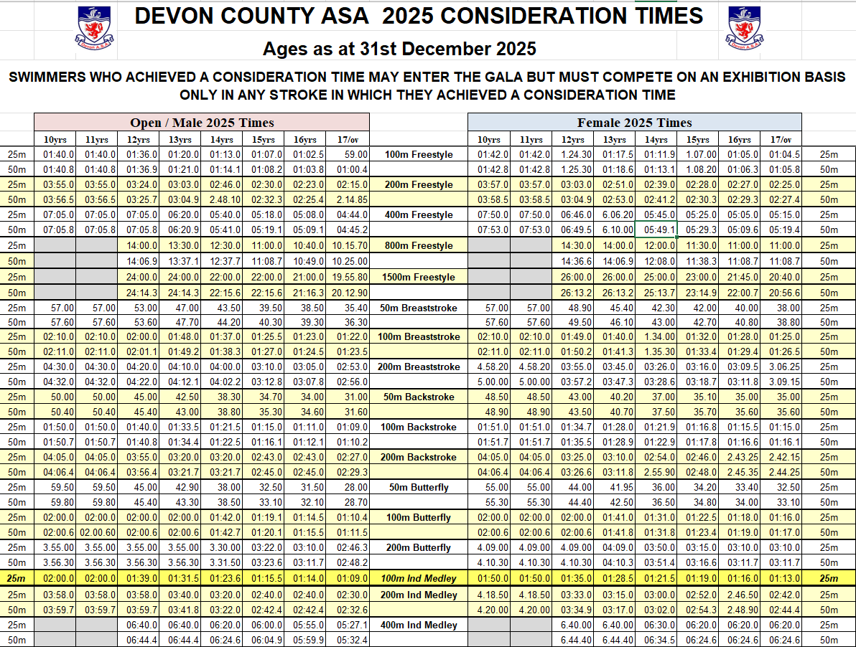
Paragraph 20: Devon consideration times

