


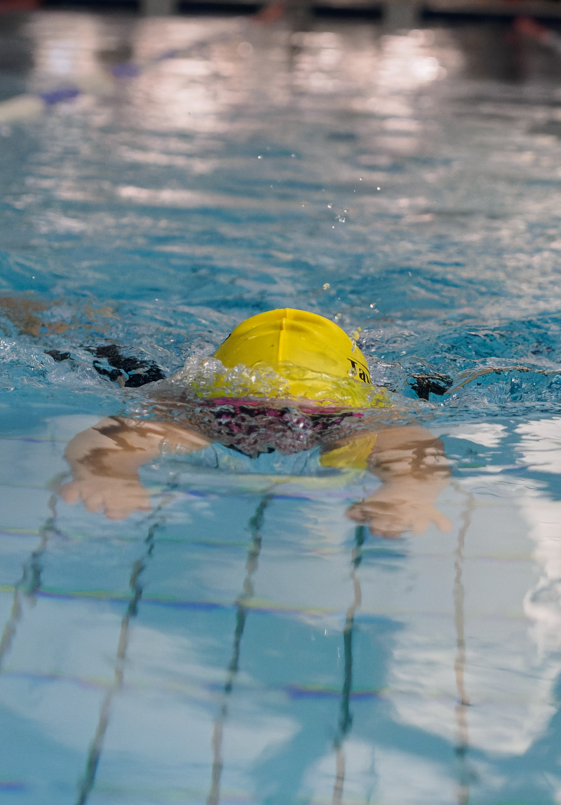

DARTMOOR SPRINT MEET
DEVELOPMENT GALA, BY INVITATION
EXMOUTH LEISURE CENTRE
Saturday 7th March 2026

50m all strokes
100m IM
Age groups: 8, 9, 10, 11, 12, 13, 14, 15+.
(Ages as at 7th March 2026)
£6/ event; £25 for all five events

Heat Declared Winners
Awards to first 6 in each age group - 10 and under
Awards to first 3 in each age group - 11 and over

Entry Administrator: Caroline Furze on taviswimclubcompetitions@gmail.com

Closing date Wednesday 18th February 2026
NOT first come first served: if oversubscribed, entries will be reduced by random selection

Level 4 Licence: 4SW260343
Clubs participating: Exmouth, Tavistock, Exeter City, Newton Abbot, Plymouth RNRM, Sidvale Sharks + 2 TBC
Dartmoor Sprint Meet
Saturday 7th March 2026
Swim England Level 4 Licence 4SW260343
PROMOTERS’ CONDITIONS AND INFORMATION

- The Dartmoor Sprint Meet is licensed at Level 4 and shall be held under Swim England Laws and Regulations and Swim England Technical Rules of Racing. The promoters are Tavistock Swimming Club and Exmouth Swimming Club.

- This is a “by invitation” Level 4 meet to which a maximum of six other clubs will be invited.

- The competition will be held at Exmouth Leisure Centre, The Royal Avenue, Exmouth EX8 1EN. The pool is 25m long, with a depth of 2m at the start end and 1m at the turn end. It has six lanes with anti-wave lane ropes.

- Manual timing will be in operation with the addition of Dolphin Infinity timing if available. There will be no backstroke ledges.

- Entries will only be accepted from competitors registered as Club Train or Club Compete members of Swim England and who are members of clubs invited to enter.

- Age Groups: competitor’s age groups shall be defined as on the day of the meet, 7th March 2026.
Open/Male: 8, 9, 10, 11, 12, 13, 14, 15+.
Female: 8, 9, 10, 11, 12, 13, 14, 15+.

- The Female category is for birth sex females in accordance with Swim England’s Transgender and Non-Binary Competition Policy. By entering the ‘Female’ category, a swimmer confirms that their birth sex is female. If meet software lists the Open/ Male category as Male, this should be taken to mean Open/Male (i.e. any competitor not eligible for the Female category).

- This is primarily a Development gala aimed at swimmers new to competing and those less experienced in competition.

- Any swimmer who, at the closing date of entries for the Meet including those entered early, has achieved since 1st March 2025 a time faster than the published upper limit may not enter that event or will be entered as a time trial swim if time permits. Should it transpire at any stage that a swimmer has submitted an ineligible entry or not declared a faster time, then the entry will be rejected and the fee forfeited

- Swimmers without times are welcome. If possible, please give a coach approved time in the meet file rather than NT, as this will improve seeding of the heats and help with efficient use of available pool time.

- Disabled swimmers are welcome and will be seeded according to entry times alongside all other entrants. Please let the promoters know as early as possible of any special requirements, including if a secondary strobe is required. Swimmers with a Certificate of Exception should ensure this is presented to the referee prior to each session, as failure to do so may result in disqualification.

- For swimmers who have a SE/IPC swimming classification which has been notified to the promoters in advance, medals will be awarded on a multi-disability basis to the top three in each event: that is, the three who, across all age groups, are nearest to the World Record (measured on a percentage basis) within their own classification. Clubs are responsible for sending a copy of the competitor’s SE/IPC classification to the promoters with their entry or, if the classification is made after entry, as soon as they receive it. If a disabled swimmer has not yet been classified, the promoters may at their discretion accept an informal classification made by the swimmer’s coach.

- Medals will be awarded to swimmers placing 1st, 2nd and 3rd in all age groups and all events. In addition, ribbons will be awarded to swimmers placing 4th, 5th and 6th in the age groups 8, 9 & 10 years.

- Heats will be mixed and will be swum in “spearheaded” seeded heats (slowest heat first), from submitted times, with declared age group winners.

- All events will be HDW.

- Competitors must report to the stewards at the marshalling area at least three heats prior to their heat. It is the responsibility of coaches and swimmers to ensure that swimmers report to the marshalling area in good time. Any swimmer not reporting may be deemed to have withdrawn from that event.

- Swimmers must have passed the SE Competitive Start award in order to start on the blocks. All other swimmers must start in the water.

- All starts will be over the top where possible.

- As many entries will be accepted as time and space allow. The promoters may limit entries if the meet is oversubscribed and would otherwise risk over-running the time available or overcrowding the space on poolside. After that, scratches will be made at random across all entries.

- The promoter reserves the right to amend the Programme of Events, with the agreement of the referee, to ensure the smooth running of the meet.

Entries
- All entries must be made electronically (unless agreed beforehand). After the closing date, clubs will be given the opportunity to check entries to correct errors.

- The submission of entries indicates acceptance of the conditions in this meet pack. All participating competitors are deemed to be aware of these conditions, and it is each participating club’s responsibility to make their members aware of them.

- The promoters use a computer to manage entries and results. By submitting entries to the meet consent is given, as required by the Data Protection Act 2018 and in line with GDPR 2018, to the holding of personal information on computer. Personal data such as name, club, entered/achieved times may be made public prior to, during or after the meet (e.g. programs, results, etc.).

- Entry Fees - £6 per event; £25 for all five events.

- Closing date for entries is 23.59 on Wednesday 18th February 2026. Dates of birth, Swim England numbers and fees must accompany entry. BACS to Tavistock Swimming Club; sort code: 08-92-99 (Co-op); account number: 67264478 using reference ‘club name & DART’. Please send Hytek entry file, a pdf entry report, a summary of fees and a screenshot of payment to taviswimclubcompetitions@gmail.com. Failure to submit payment may lead to a club not being permitted to compete.

- Refunds will be given for withdrawals up to 23.59 on Sunday 22nd February 2026 or if a swimmer is scratched from an event by the organisers. No other refunds will be given.

- Late entries, including deck entries, may be accepted at the discretion of the promoters if the event is undersubscribed.

Behaviour and photography
- On acceptance of entries, the swimmer and any supporters agree that their behaviour will be appropriate and respectful, and they will abide by these conditions and any rules of the venue. Failure to do so could result in removal or refusal of entry.

- All competitors and other club representatives on the poolside shall comply with any instructions given by Leisure East Devon staff and meet officials and any safety precautions in operation at the centre.

- Changing on poolside is forbidden and the changing village must be used.

- The use of any device with video or photo capture capability is strictly prohibited in the toilets, changing rooms or changing areas at any time. Strict sanctions will be imposed if this rule is broken.

- The promoters do not accept responsibility for any loss or damage to property, however caused. Valuables should be left at home. Lockers are available in the changing rooms and should be used for the safekeeping of other belongings. No large bags are allowed on poolside.

- In line with Swim England & Wavepower guidance, anyone wishing to take images (photo or video) are requested to focus on their own children as much as reasonably possible and to avoid including other children in images, particularly if those images are being shared with family and friends or through social media platforms. The full Swim England guidance on Photography can be found in Wavepower, the Swim England Child safeguarding policy and procedures, available at http://www.swimming.org/swimengland/wavepower-child-safeguarding-for-clubs/
Flash photography is not permitted at the start of any heat.

Cancellation, changes etc.
- If the meet, or any event(s) within it, is cancelled, postponed or altered due to circumstances beyond the control of the promoters, competitors will not be eligible for a full refund of their entry fees. Proportionate refunds will be made if possible once all costs have been paid. If the meet has already begun when it is cancelled, there will be no refunds.

- The meet promoter will make every effort to run the meet at the advertised licence level. In any situation that the meet must be run unlicenced, competitors will not be eligible for refunds of their entry fees.

- Any matters concerning the meet not covered in these conditions shall be dealt with in accordance with the laws of the sport and at the discretion of the promoters and the referee. The promoters reserve the right for the referee to change these conditions if necessary to ensure the smooth running of the event.

Officials
- To ensure that the meet can run effectively and efficiently, all participating clubs are requested to assist by supplying officials and other volunteers. It would be appreciated if each club could provide at least two officials. Refreshments will be provided to all volunteers and a light lunch to those who are on duty all day.

- Officials working for a whole session will be offered reimbursement for the costs incurred to officiate at the meet at the rate of 45p/ mile from their home address for travel. Parking will be reimbursed on proof of payment (e.g. a screenshot), up to a maximum of £12.

Official decisions
- The referee’s decision on all swimming matters is final.

Coach/ team manager passes
- Coach/ team manager passes will be free.
  - All Teams must be accompanied by at least one Level 2 or Swim England Swimming Coach who must have current safeguarding and DBS passes.
  - Maximum of three coaches/team managers per club on poolside per session, subject to any reasonable additional requirements for disabled swimmers.
  - Team Managers on poolside must be TM1 qualified and be DBS checked.

Spectators
- The final meet programme will be emailed to participating clubs a day or two before the meet to circulate to their members. No programmes will be printed, and the meets will not be live streamed.

- Admission for spectators will cost a maximum of £3/ person, children under 14 free. Please note that seating for spectators is very limited.

Summary of events/age groups
Two sessions: only swimmers taking part in the session will be allowed on poolside.

Morning session: warm up 11.20am (TBC); start time TBC: swimmers aged 8, 9 and 10.
Afternoon session: warm up TBC once entries received: swimmers aged 11, 12, 13, 14 and 15+ years.

Each session will comprise the following events in this order:
50 fly
50 back
100m IM
50 breast
50 free

Cut-off times
Open/Male No Faster Than limits
Open/Male Event | 8yrs | 9yrs | 10yrs | 11yrs | 12yrs | 13yrs | 14yrs | 15yrs+
50m Free | 20.00 | 41.50 | 41.50 | 37.00 | 35.00 | 32.50 | 29.50 | 28.25
50m Breast | 20.00 | 57.00 | 57.00 | 53.00 | 47.00 | 43.50 | 39.50 | 38.50
50m Back | 20.00 | 50.00 | 50.00 | 45.00 | 42.50 | 38.30 | 34.70 | 34.00
50m Fly | 20.00 | 59.50 | 59.50 | 45.00 | 42.90 | 38.00 | 32.50 | 31.50
100m IM | 20.00 | 02:00.0 | 02:00.0 | 01:39.0 | 01:31.5 | 01:23.6 | 01:15.5 | 01:14.0

Female No Faster Than limits
Female Event | 8yrs | 9yrs | 10yrs | 11yrs | 12yrs | 13yrs | 14yrs | 15yrs+
50m Free | 20.00 | 43.00 | 43.00 | 35.60 | 34.50 | 32.30 | 30.30 | 29.40
50m Breast | 20.00 | 57.00 | 57.00 | 48.90 | 45.40 | 42.30 | 42.00 | 40.00
50m Back | 20.00 | 48.50 | 48.50 | 43.00 | 40.20 | 37.00 | 35.10 | 35.00
50m Fly | 20.00 | 55.00 | 55.00 | 44.00 | 41.95 | 36.00 | 34.20 | 33.40
100m IM | 20.00 | 01:50.0 | 01:50.0 | 01:35.0 | 01:28.5 | 01:21.5 | 01:19.0 | 01:16.0

Any queries about the meet, please contact Caroline Furze
Email: taviswimclubcompetitions@gmail.com

Entry Fees Summary Sheet

Please e-mail this completed entry fees summary sheet, Hytek files and
Hytek entry reports to: taviswimclubcompetitions@gmail.com

CLUB
CONTACT NAME
TEL NO
E-MAIL

NUMBER OF ENTRIES IN TO 1-4 EVENTS |  | @ £6
NUMBER OF ENTRIES INTO ALL 5 EVENTS |  | @ £25
TOTAL AMOUNT DUE

PAYMENT DETAILS

Payment is by BACS to: Tavistock Swimming Club; sort code: 08-92-99 (Co-op); account number: 67264478
Please use the reference CLUB NAME – DART
Closing date: Wednesday 18th February 2026

